**DAILY ONLINE ACTIVITIES SUMMARY**

|  |  |  |  |  |  |  |
| --- | --- | --- | --- | --- | --- | --- |
| **Date:** | **18/06/2020** | | | **Name:** | **Apoorva K N** | |
| **Sem & Sec** | **VI & A sec** | | | **USN:** | **4AL17CS012** | |
| **Pre-Placement Training Summary** | | | | | | |
| **Pre placement training** | **9:00 am to 11:00 am - Programming in C**  **11:00 am to 1:00pm - Applications of python in DA and ML** | | | | | |
| **Faculty** | | **1.** **Mr. Vivek Sharma**  **2.Dr. Mohideen Badhusha** | **Duration** | | | **5 hr** |
| **Assessments** | | | | | | |
| **Problem Statement:**   1. Examples and Exercises on python. | | | | | | |
| **Status: Completed** | | | | | | |
| **Uploaded the report in GitHub** | | | **Yes** | | | |
| **If yes Repository name** | | | <https://github.com/Apoorva-K-N/pre-placement-training> | | | |
| **Uploaded the report in slack** | | | **Yes** | | | |

**Training snapshots:**

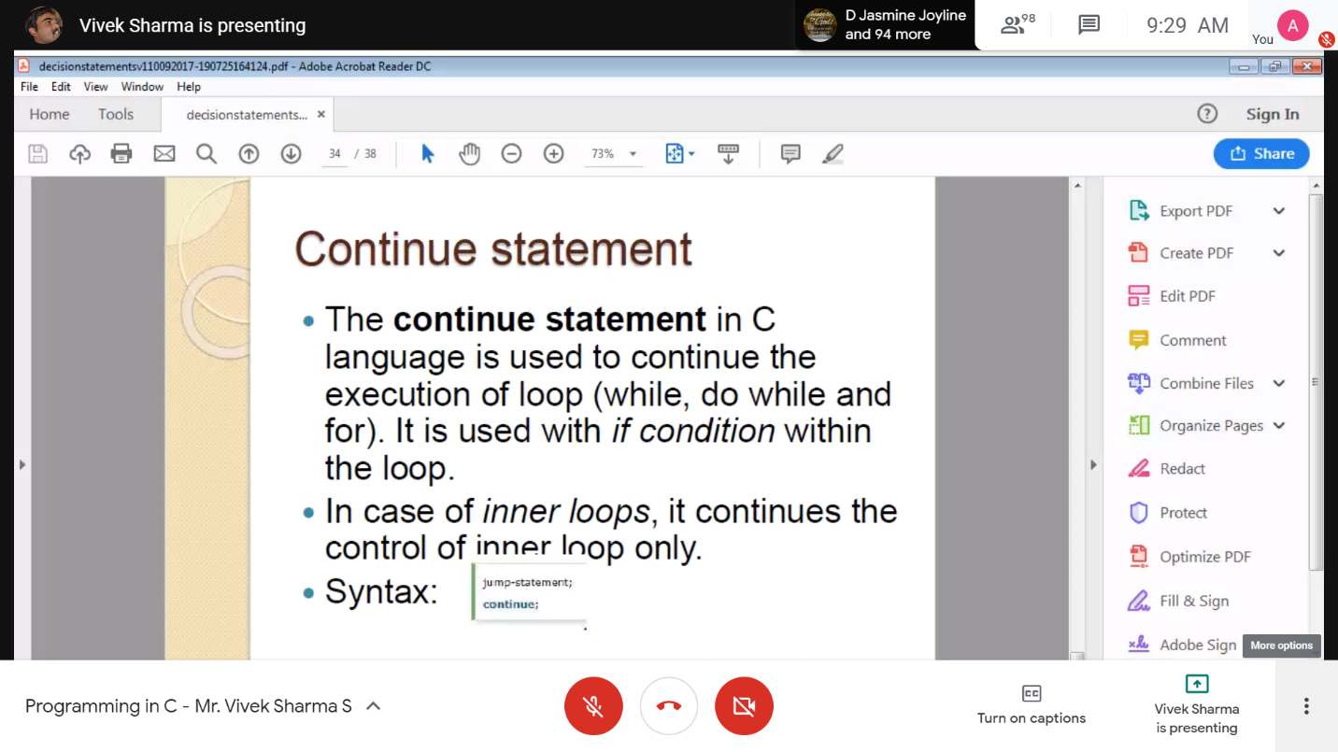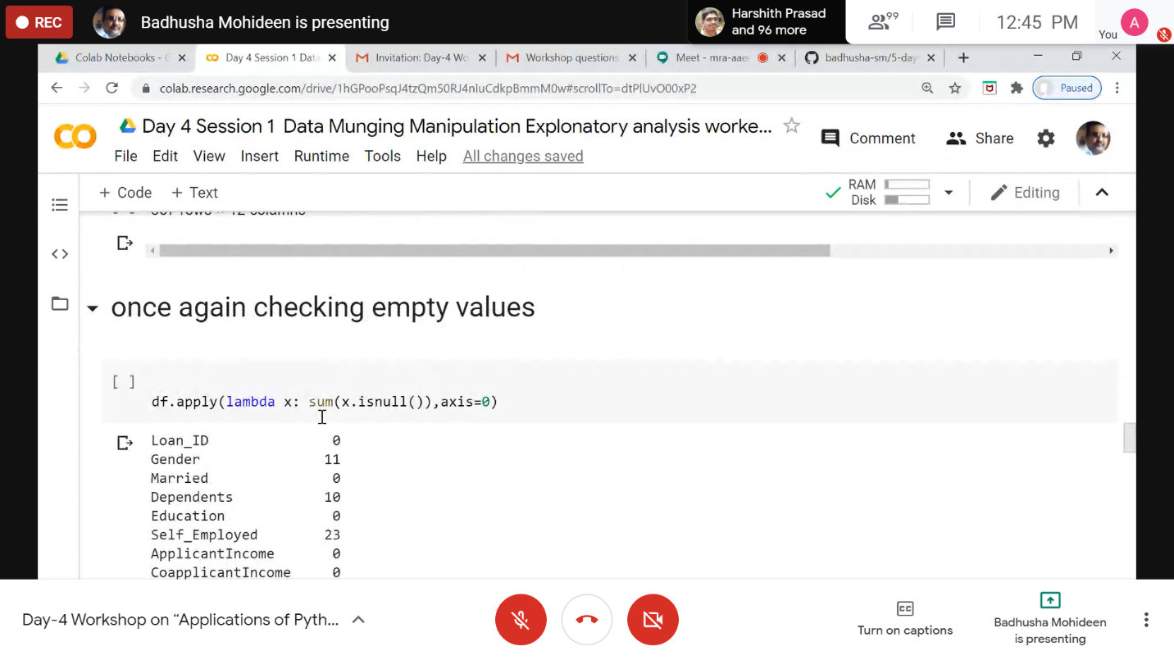

**Assessments:**

**Uploaded in GitHub account and respective link is provided below.**

**Python programming:**

<https://github.com/Apoorva-K-N/Application-of-python-programming-in-DA-and-ML>

**Report link:**

<https://github.com/Apoorva-K-N/pre-placement-training>